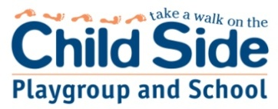
Child Side PLAYGROUP AND School follows child protection and protective behaviour processes

Our Child Side vision and curriculum delivery underpin all we do:
Our Vision Statement:
“REIEA and Child Side School have a vision for a just and civil society that values our shared humanity, fosters strong democratic communities, recognises the uniqueness of each individual, and appreciates diversity... We recognise that all children have a right to be heard, to be respected, and to feel a sense of belonging to their family, school and community. We see this as a foundation for becoming responsible citizens of the world.” REIEA- Reggio Emelia Information Exchange Australia
Curriculum delivery at Child Side supports Goal 2 of the Melbourne Declaration on Educational Goals for Young Australians (Commonwealth of Australia, 2009, p. 5)
All young Australians become:
• successful learners
• confident and creative individuals
• active and informed citizens
The Child Side rudder:
“The purpose of life is life with a purpose.”- Dr Louise Porter.

“All children learn, grow and master life skills at differing rates. There is no competition in raising children.” Maggie Dent

“Resilience refers to the ability to successfully manage life and adapt to change and stressful events in healthy and constructive ways. It is about the capacity to bounce back from positive and negative life experiences. To develop emotional and psychological buoyancy in childhood gives our kids a better prospect of being able to thrive as adults.”

Maggie Dent

