Child Side YAC Handbook 2023:
The purpose of education is to
help every person flourish,
no matter what happens in life.
“Every person deserves the opportunity to learn in a way that speaks to their strengths, gives them a sense of belonging, connects them to the real world and excites them about their future prospects.”
Viv White: Co-Founder, AM and CEO of Big Picture Education Australia BPEA
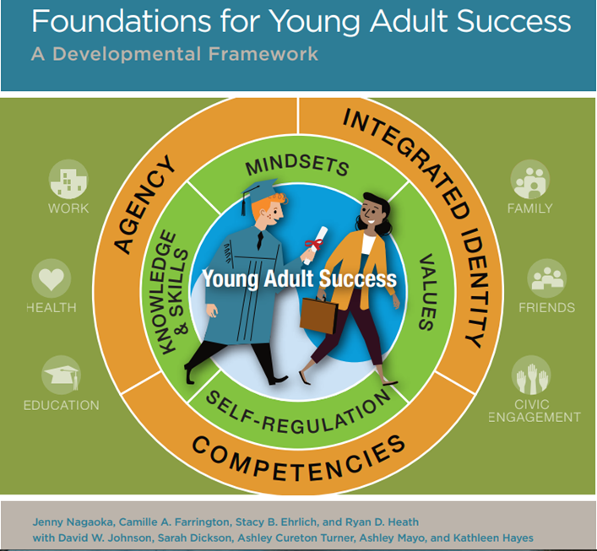
YAC = Young Adolescent Cluster for Years 7-10.
Young Adolescents build the foundations for Young Adult success in life through active engagement and reflection with home, school, community.
Young Adolescents build foundations for life success through actively developing their capabilities:
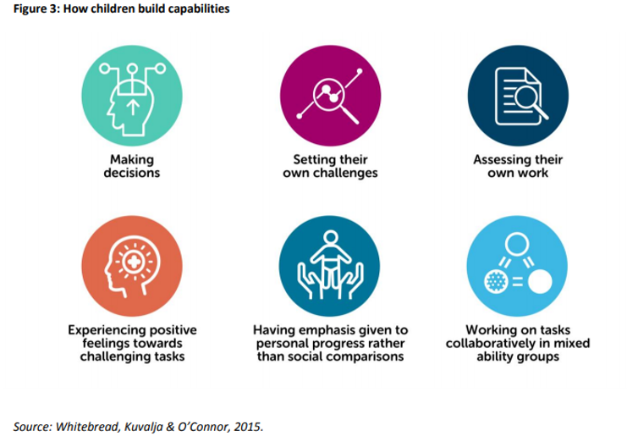
Young Adolescents’ Daily Work as a YAC is to:
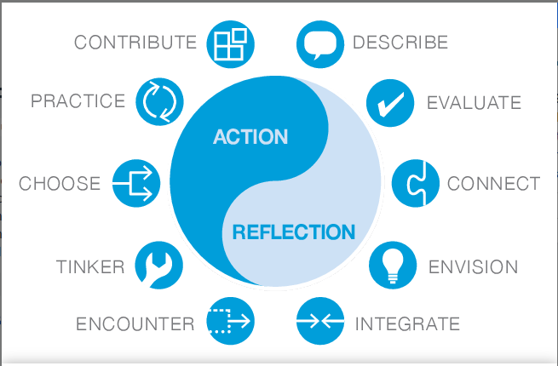

Young Adolescents develop Reciprocal Relationship Skills within their cluster and through purposeful interactions and work with adults (all staff, parents, community) and other children (K-10). They learn through positive adults that healthy, respectful and constructive relationships need skills, effort and maintenance. Relationship skills are taught:
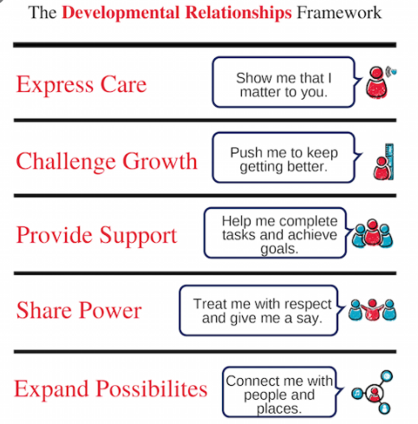
Young Adolescents develop Physical Literacy through home, school and community for health, well-being and to enhance ALL other learning. They only become competent, confident and motivated to move through personal effort, commitment and a real purpose. They engage in learning how to effectively run community sports and events.
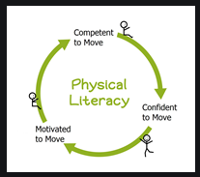
Young Adolescents learn ‘employ-ability’ skills through all their daily interactions and through internal internships within the school community, in particular on Wednesdays:
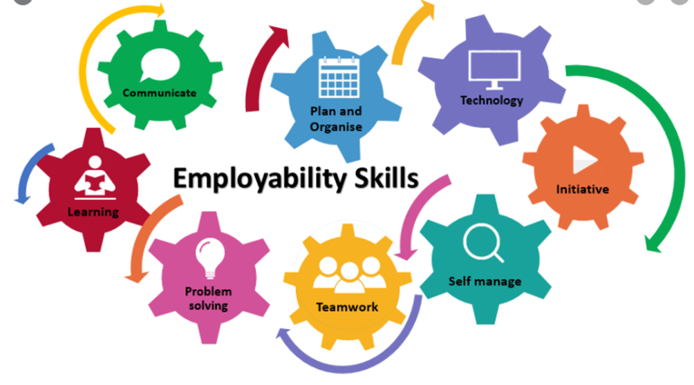
Young Adolescents develop their internal assets building character strengths through many intentional, authentic opportunities. They purposefully interact with different adults and other children to use and challenge them to grow these character strengths and to gain support, in particular, through Impact Projects and working as internal interns:
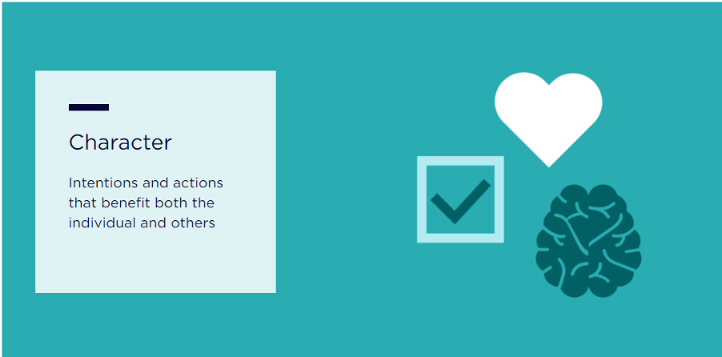
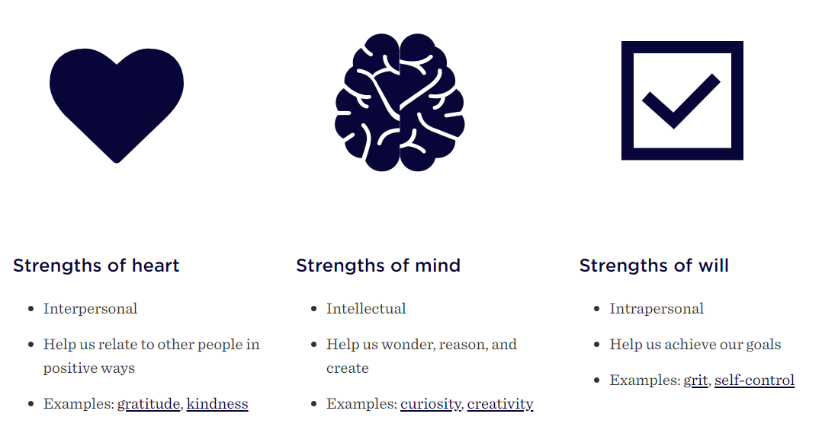
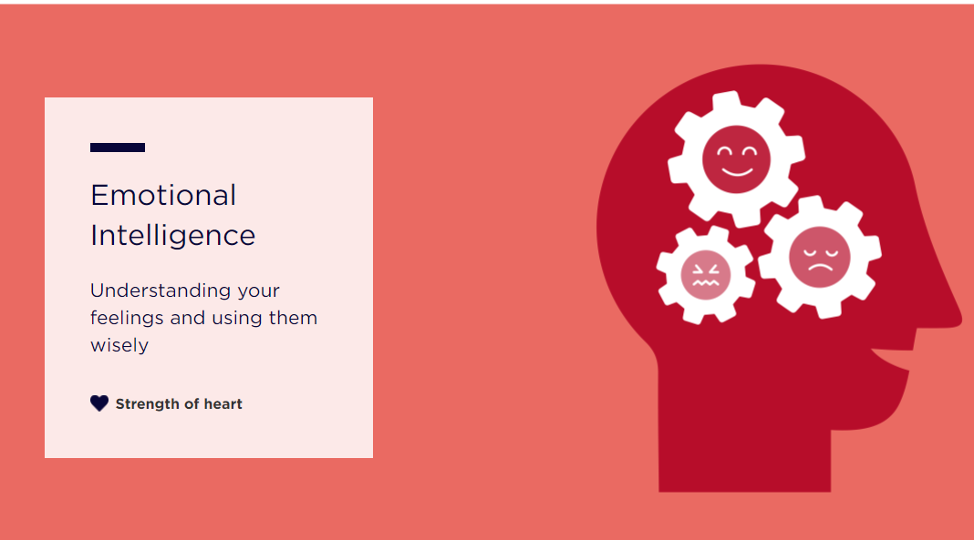
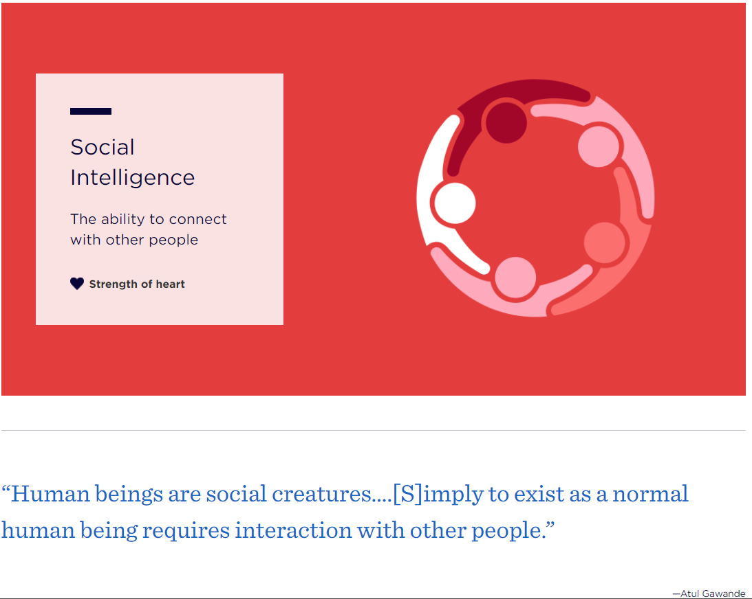
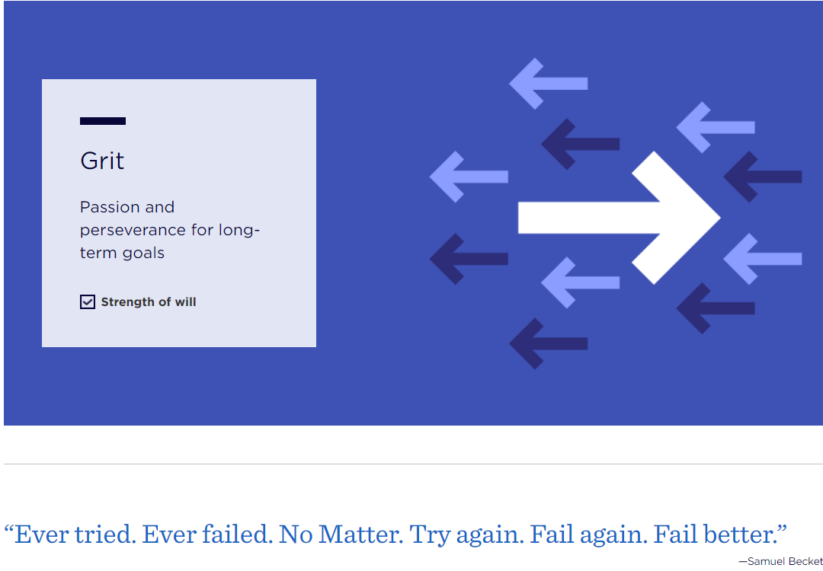
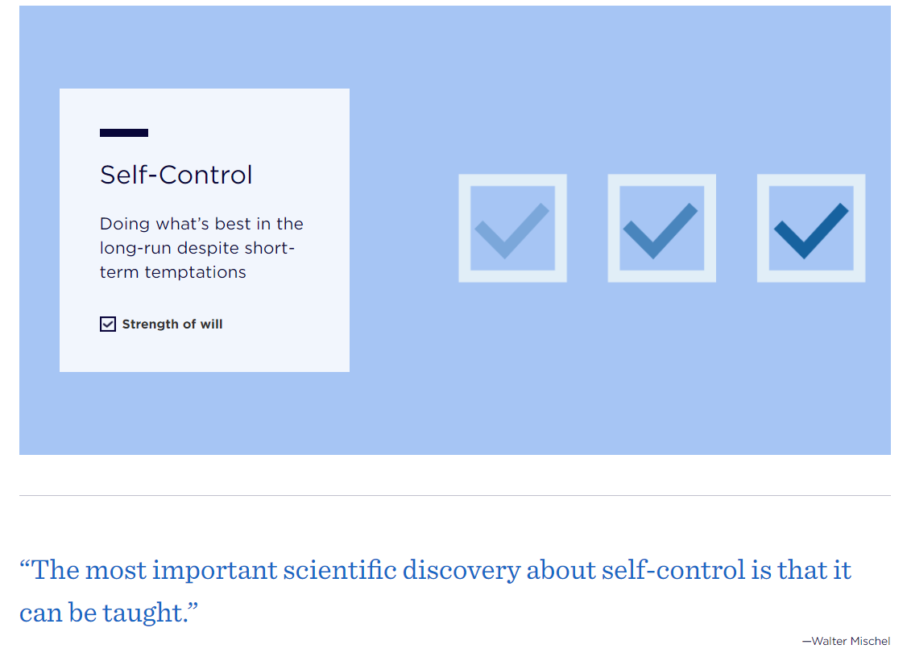

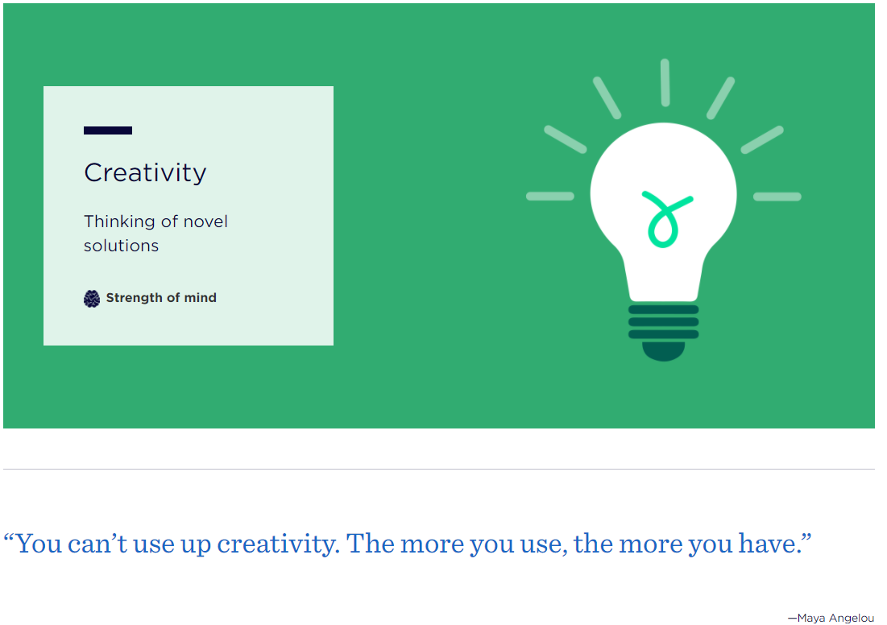
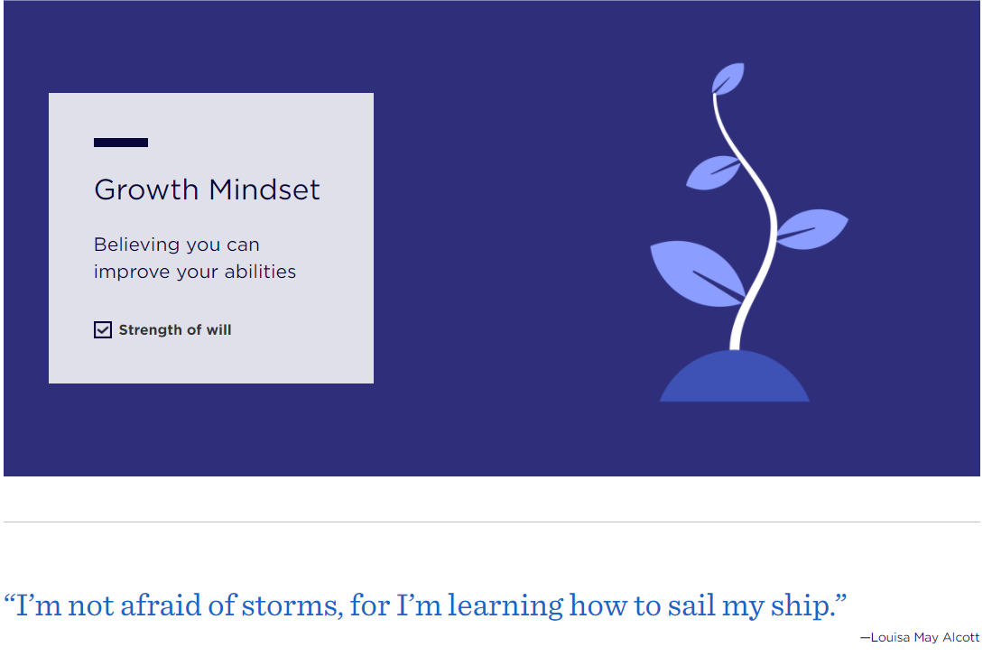
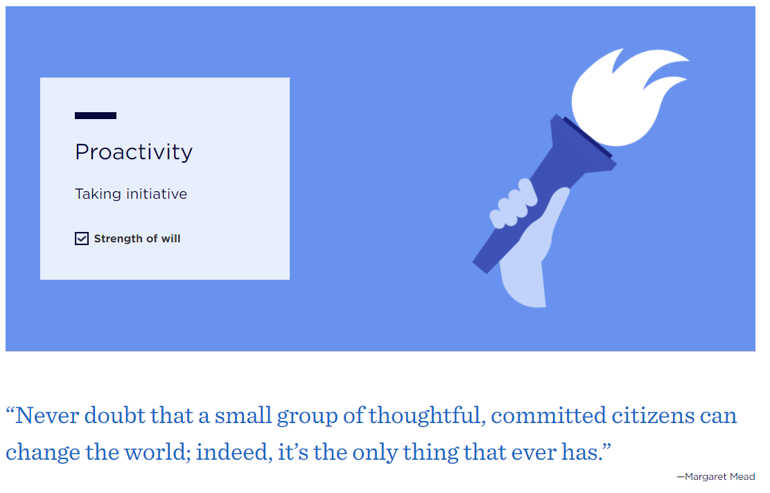

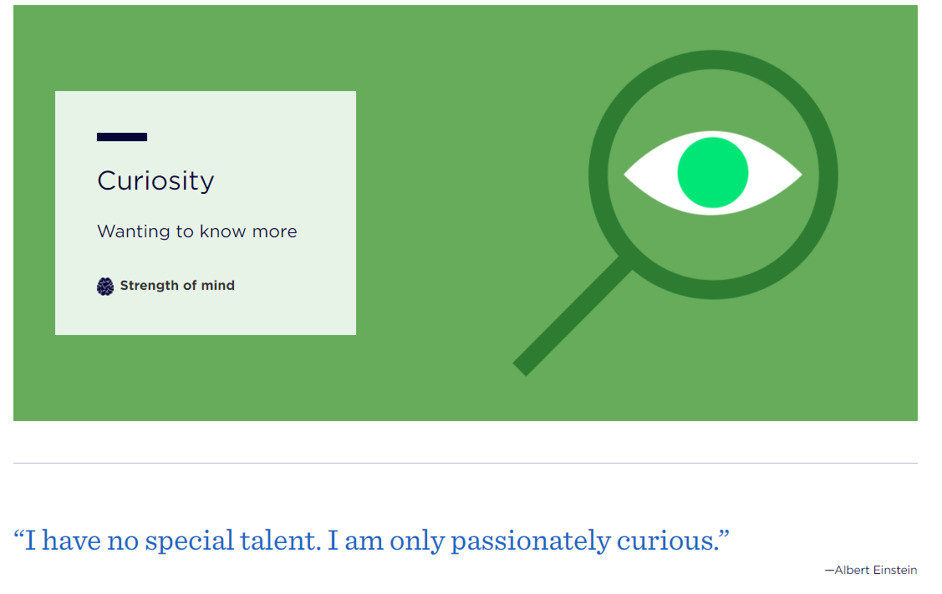
https://characterlab.org/
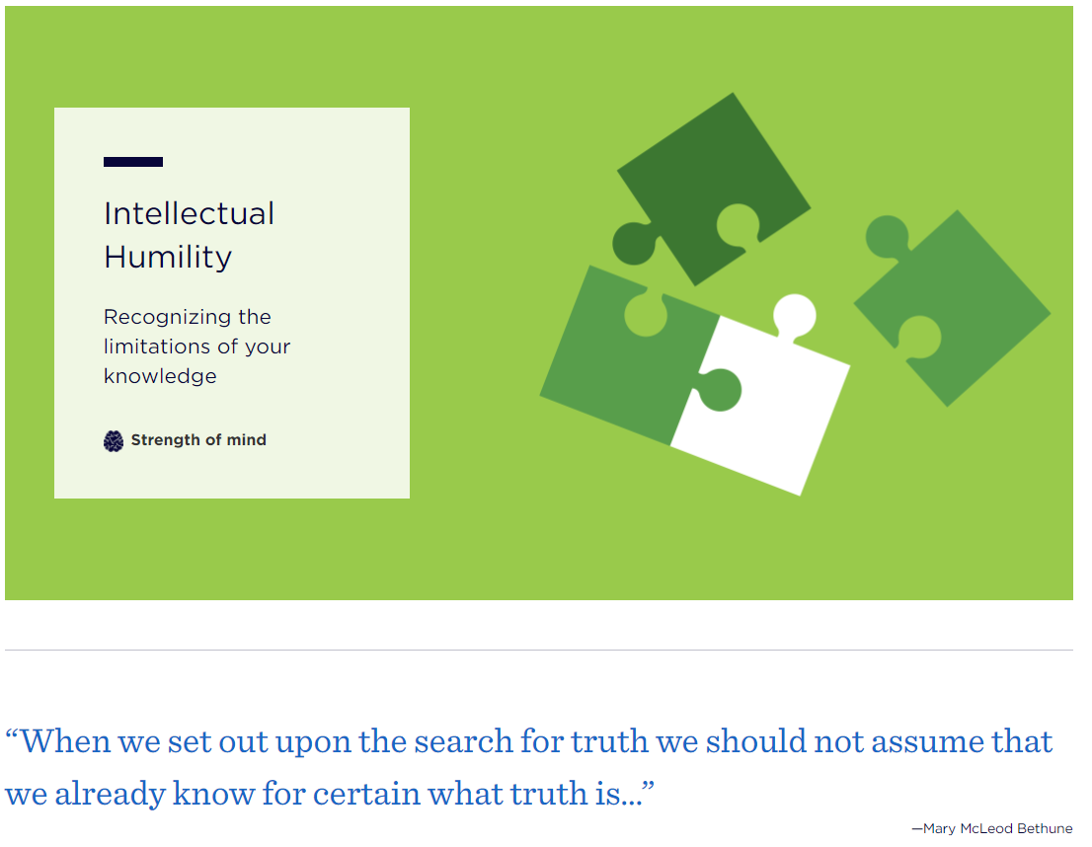
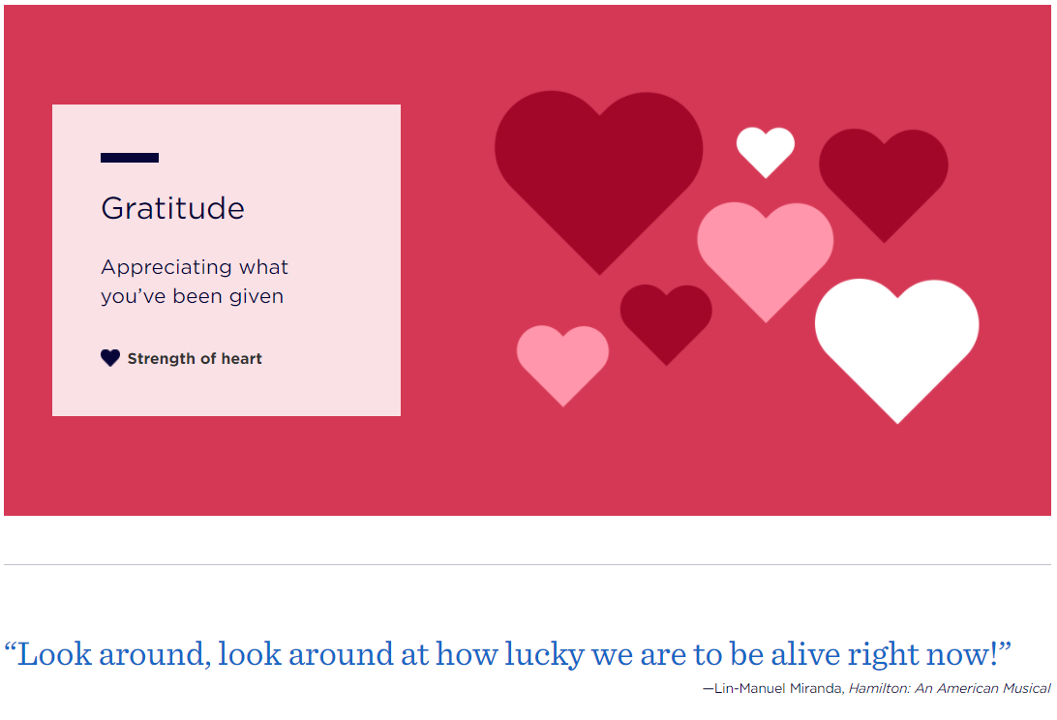
Young Adolescents (YACs) will develop their technical competencies and capabilities to use literacy, numeracy and ICT across all areas of curriculum and life. These are the ‘floors’ of their learning focus NOT the ‘ceiling’ or end-goal. Assessment is around use, practicality and effectiveness without any need for test scores and exam results to track personal progress. YACs learn and use communication, literacy and numeracy and ICT skills through the whole shape of their day and their week, including preparing for and presenting exhibitions, internships and Impact Projects.
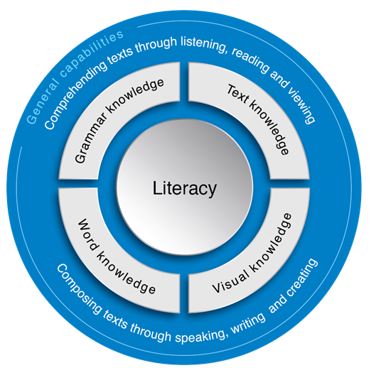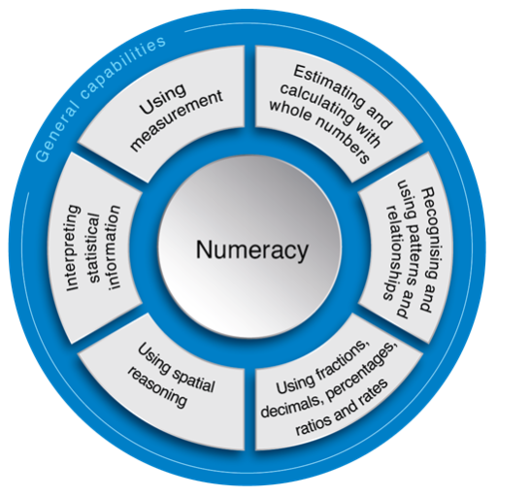
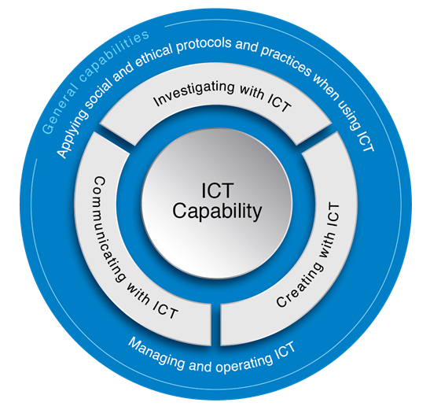
ICT= Information and Communication Technology capability
Young Adolescents interact with Authoritative Mentors and Educators who have high, demanding expectations, especially around personal effort, and who set boundaries BUT who offer support as MKO and MEOs (More Knowledgeable Others and More Experienced Others) and give specific, tailored feedback to enable growth and progress.
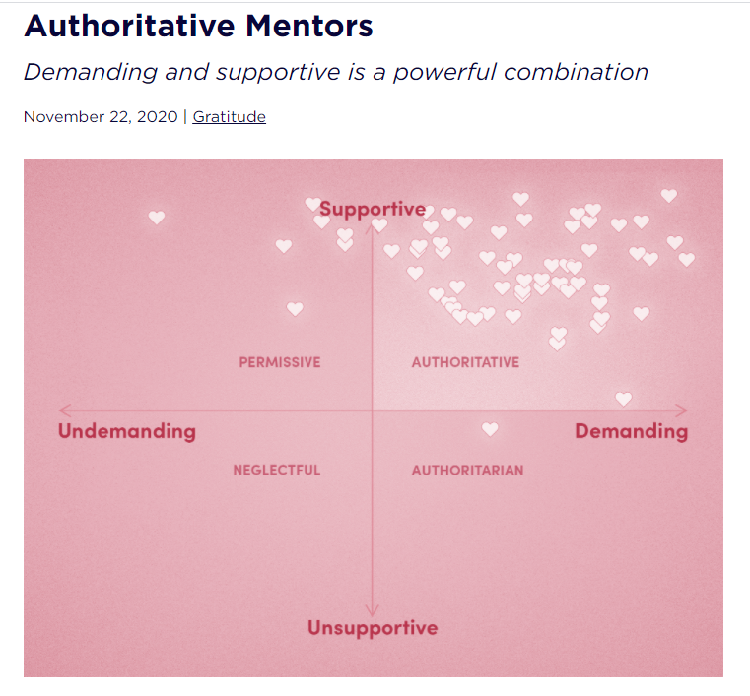
Young Adolescents (YACs) will need to grow and use their levels of Grit, Curiosity, Intellectual Humility, Self- Control and Growth Mindset as they work with a wide range of diverse others (adults and children), those ‘like’ and ‘not like’ themselves. This is the purpose of Child Side School: to learn to and expect to work within codes of conduct as an ethical, active crew member rather than be treated as a passenger, picking and choosing around ‘likeability’. To do this, young adolescents need parents and caregivers committed to supporting the way we work and being an active part of their learning team; challenging them to grow and expanding their possibilities, even though they are experiencing tumultuous growth spurts and reshaping their self-identities during puberty.
YACs learn in a social setting but will need to learn not rely on friendships or personal ‘likeability’ to frame their own worth or willingness to be at school. The Young Adolescent Cluster is their real work place with their real work-colleagues who range in age, interests, personalities, skill sets and skill levels (just like at home in their family, neighbourhood, sporting or interest clubs and adult workplaces). They will learn highly valuable work place skills and intergenerational interaction skills that will ensure greater opportunity for Young Adult Success (their futures start NOW, not at the end of Year 10 or 12!) Friendships will need parent commitment to nurture outside of school within a range of healthy settings.
YACs will engage frequently with academic rigor and high adult expectations to pay attention, practice and to make an effort even if the point of relevance (example technical Maths, English or Science skills) escapes them at this point in their young lives.
Parental or Care-Giver Commitment:
To grow the competencies and their capabilites to experience success NOW as a young adolescent AND future success as Young Adults they need adult commitment from HOME around:
- CONSISTENT attendance AND being at school for each full work day to reduce impact on self and others (it requires parental commitment and dedication to bring along tired, growing bodies with rapidly changing moods, levels of resistance and fluctuating levels of resilience: we understand as parents ourselves and as MEOs- More Experienced Others working with adolescents in group settings!) Parents are expected to attempt to make medical or dental appointments and ALL other appointments after school hours, UNLESS unavoidable and at very short notice. If unavoidable, YACs are expected to return to school after the appointment or attend school before they are picked up later in the day. This particularly impacts upon their internships if they miss whole days for appointments for themselves or siblings/family members
- good healthy habits and boundaries at home (around sleep, screen time, protective behaviours, respectful relationships, food, exercise, social media, reflecting on issues and concerns, bringing home or social life to school and vice versa, attitudes and exposure towards addictive substances such as alcohol, drugs, prescription drugs, smoking and readily accessible addictive, harmful material such as pornography, racism or ‘trolling’)
- nutrition at home: what young people, who are rapidly growing, maturing and transforming, eat and drink matters, especially variety. Nutrition effects energy, engagement and mood levels impacting short-term on both themselves AND others in their cluster (and family) and long-term on their own health and capability for resilience. ‘Hangry’ is a real thing! Fussy, highly restricted eaters put their health at risk long term and this also impacts upon their energy levels and willingness to engage and concentrate during adolescence. Growing bodies can snack on healthy food throughout the day if required, especially for YACs who engage in high levels of activity outside of school through sport or farmwork. Full water bottles from home are required everyday.
- respectful relationship skills when dealing with: hard, boring, complex academic rigor and technical skill builders like Maths, English and Science(pity the educator or mentor!) or with those ‘not like’ themselves and when approaching inevitable social conflict; when being ‘told/nagged what to do’ when needing reminding to respect workplace codes of conduct and personal boundaries set by others AND when interacting with others when inexplicable mood swings are exasperated by hormones (this is VERY real for both genders, through puberty and at the other side of physical growth: menopause! YACs need to learn to support themselves and others going through these turbulent times, understanding but not having to accept disrespectful or harmful behaviours). Please be aware how your YAC talks about both themselves and others, adults and other children, and attempt to constructively re-frame things for them and with them. Words and tones of voice impact relationships greatly and adolescents in particular, can be highly sensitive to choices of words and tones spoken to them or about them and also extremely insensitive when talking to or about others. Constructive self-talk is extremely important too for young adolescents to hear positive self-talk by adults and to have adults help them re-frame their perceptions about themselves and events through changing their self-talk.
- appropriate clothing and shoes: covered shoulders, cleavages, midriffs (from above and below for both genders) and covered thighs plus hats to shade faces, ears and necks, shoulders, tops of legs… as part of sun-protection AND active physical learning and daily exercise (including ROMWOD- Range of Motion Workout Of the Day on the floor); non-offensive nor provocative wording and pictures on clothing (T-Shirts, hats, socks etc)
- following through with essential work at home that they have missed or not been able to complete (at the discretion of the mentor/educator), especially if needing to stay away from home longer than in pre-COVID times, due to persisting low levels of symptoms: contact educators and access on-line work through See Saw; or if late for independent work time (morning work). YACs need parents to commit to help them be on time to reduce impact on selves and others, they are part of a community NOT isolated self-learners. Foundational skills around literacy and numeracy need practice and use to stay useful. YACs engaged as internal interns (Years 7-10) or external internships (Year 10) will negotiate and consult with educators regarding relevant work parallels due to working away from their cluster. This is very different to being away on holiday, being unable to get to school for many reasons, not returning to school after an appointment (YACs like to take the whole day off if unavoidable times for medical or dental appointments fall within the school day). Attending functions or appointments for other siblings or being late because of siblings does impact, especially at a YAC level. This impacts not only on themselves but on others too, including the educators. Adult work places are not sustainable nor is employment viable with inconsistent attendance. YACs need parental/caregiver commitment around consistent attendance or commitment to catch-up, follow through and to actually do this, not just say it. We understand and we can help at point of need. We understand ourselves, as working parents, that juggling family, work and school commitments is a great deal of work whilst trying to maintain parental health and well-being too! We understand the travel around the location of our school and inflexibility of other workplaces and appointments, having a number of children, elderly parents and/or properties to care for… Regular communication with educators helps and accessing the Child Side community through the closed CSS Facebook group for reciprocal support is advised for those tricky times we all have. Dis-engagement from work and dis-connection from others are often the serious results from higher levels of absenteeism and shortened days. Others inevitably tend not to include, rely and depend upon any YACs frequently ‘missing’ from the action!
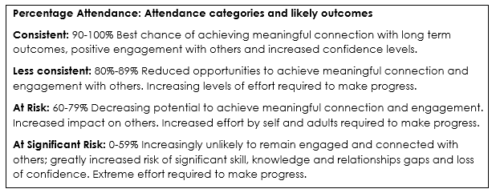
- following through with integral Child Side assessment commitments such as termly exhibitions- if children are away on the day or during the lead up they will need to prepare an alternative assessment/experience in consultation with educators and find ways to support and give back to other team members who are impacted by their absence (YACs work in teams frequently to collaborate and co-operate, interacting with each other often as MKOs and MEOs, so being away does impact signficantly, including around making lunches, clean ups, shared projects etc- everyone matters). Exhibitions of learning are not personal choices to attend or not. Exhibitions challenge growth and can be overwhelming but are an essential part of how we work, so if missed, require alternative ways to express and communicate learning (without overloading the educators). The same goes for government mandated requirements such as OLNA or NAPLAN, required catch-up days take a whole educator out of action for one child
- following through with after hours practice and training, especially for the Annual Term 3 fire-twirling which has Wednesday Early Close training expectations, evening light-up practices and attendance on the evening as their Term 3 Exhibition, families need to commit to this ‘extra’ requirement in order to make it work for the whole cluster. Our staff give up their time too so they can follow through with this wonderful Child Side ritual and authentic learning which is unique to our school and to YACs as a symbolic rite of passage
- following through with real or perceived conflict or concerns with educators and/or the school Leadership Team, please NEVER directly with other children, families or external mentors: see Child Side School Communication Policy and Flow Chart in your enrolment pack or accessible on our web-site, as is our Grievance process and parent and child Codes of Conducts. We follow a No-Blame approach and the principles and practices of “Guiding Children’s Behaviour “(Dr Louise Porter) around natural consequences NOT punishment and reward; along with Maggie Dent’s Beautiful Boundaries (around safety, respect and impact on self and others, including unintended consequences, especiallly around protective behaviours and damaging reputations of self and others)
- following through with concerns around protective or risk-taking behaviours around self OR others: parents are asked to be the ‘tellable’ adult for their child, regardless of how upset, distressed, embarrassed or angry you may feel with what they have to tell you, young people need around 5 trusted adults (NOT other children, siblings, adolescents) who will listen without predujice or fear and follow-up appropriately. The school Leadership team can be contacted on their mobiles or emails at any time, including after hours if your child is distressed or has revealed concerns around protective behaviours (on-line, face to face, concerning either themselves or others, perceived or with ‘gut feelings’ or concrete evidence). Educators and the Leadership team have been trained with protective behaviours curriculum and Mandatory reporting, there are many on-line help organisations for mental health and a range of support groups, children and families need never feel alone or shamed. Protective behaviours (especially on-line) is a constant parental responsibility, especially when young people wear head-phones (including if they are gaming, listening to music, talking with friends- real or unknown, listening to pod-casts, watching a movie etc.) Young people are very tech-savvy and have access to the whole world without ANY filters through phones and smart TVs, as well as computers. There are no longer any boundaries around what children and young people are exposed to (including within commercial and adult acceptable programmes, music, games, advertising, memes, social media, snapchats…) and can access at their finger tips 24/7 right alongside parents and educators, without them even knowing
- following through with school Codes Of Conduct and requirements, including around NO personal mobile phones at school (leave in School Office daily if required by parents to have one after school). Children and YACs can access their parent through educators’ mobile phones or the school office (with permission) and parents can directly speak to their child through the same means if required. Fitbits and other wearable technology are also NOT required at school for this age group (K-10). YAC Laptops can be and will be accessed by educators purposefully for work purposes and if any concerns are raised
- supplying and maintaining the required BYO technology, including their own laptop, charger, headphones and scientific calculator. Child Side School will load the required software. Please consult with the YAC core educator to find out the requirements and logistics
This Photo by Unknown Author is licensed under CC BY-NC

- engaging with their annual portfolio to add to, edit, provide photos and other evidence of community engagement, accreditation of courses or certificates of participation etc. These annual portfolios are a joint venture prepred between parents, the YAC and educators to reflect and communicate learning and experiences both at school and outside of school, teaching young adolescents how to become self-advocates and value their own effort and range of work skills, products and value adding experiences beyond what is typically expected from a ‘school report’. Parents are responsible for printing and collating these annual portfolios in display books, ready for the end of year exhibition and to make available for prospective entry pathways for part time jobs, Year 11 and 12, TAFE, Universities, other courses of study or opportunities. These become the personal property of families. Annual portfolios expand YACs possibilities and communicate their capabilities and extensive range of skills and interests both at and beyond school, to inform and engage the reader (YAC educators, the leadership team, other parents, other YACs, Manea or Harvey Agriculture College enrolment officers, TAFE, employers, team selectors). It also enables the leadership team and YAC educator to prepare references and reliably go into promote and advocate for that YAC to help gain entry for competitive courses etc post Child Side. It authentically enables parents and caregivers to be a part of their child’s education team and process. It authentically opens up communication and support through being required to work together to prepare this time-consuming document, learning valuable communication and ICT skills and self-knowledge.
Adolescence (from Latin adolescere 'to grow up') is a transitional stage of physical and psychological development that generally occurs during the period from puberty to legal adulthood. Brain maturation continues as young adults into their early 20s.
Young adolescents enter the YACs as a caterpillar, often a tiny and very hungry/curious (or not so hungry/curious) caterpillar and take years to transform into their young adult form ready and well-prepared to spread their wings, live their lives fully and change their worlds. We cannot ignore, force or rush this process. Whilst YACs are expected to work towards personally achievable quality standards at their own pace, we cannot standardise learning or ‘make’ young adolescents work at a prescribed year level forcing them all to enter and emerge each phase at the same time, in the same way, nor grade them on their ability to all respond and behave the same way within the same year level!
Child Side School intentionally operates differently within a unique ‘small by design’ setting and a learner-centred, network-era, transformational paradigm of education. The chart below highlights some of the key contrasts between the current (mainstream, traditional, industrialised) paradigm of education and a learner-centred, net-work era (contemporary 21st century) transformational paradigm. Post Child Side destinations still operate within the ‘current’ industrialised paradigm, even if there are increasing more flexibility in some areas for some adolescents, some of the time. Post Child-Side learners are uncommonly well-prepared because they have worked and learned in a different educational paradigm at Child Side which better aligns them for success anywhere. Long term Child-siders (K-10) with committed parents/caregivers, have gone on to thrive and excel in their chosen areas beyond Child Side and Year 12, including elite sports at a state, national and international level, coaching and umpiring; undergraduate studies, masters and PHDs, world travel, TEDx talks, duxes, mentors, team captains and leaders, awards for both ATAR and VET pathways; consistent employment opportunities, stable friendships and personal relationships and navigating significant personal, health and family tragedy…
Comparison Explanation around how and why Child Side School K-10 works differently: Child Side Learners K-10 operate within a Learner- Centred Paradigm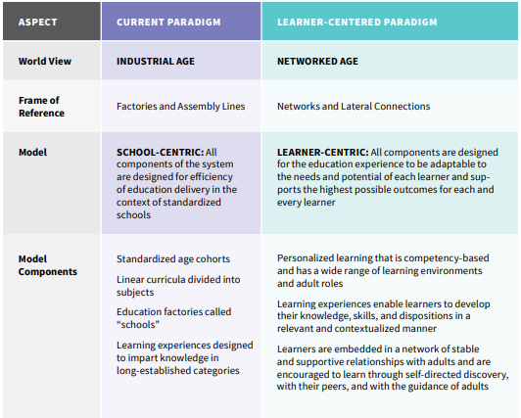

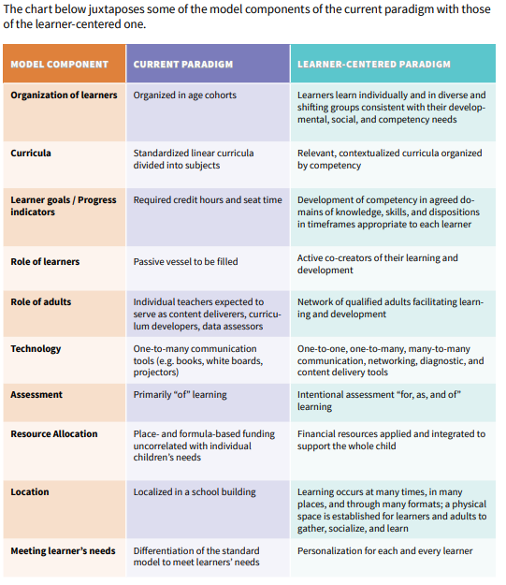
Please access these digital platforms below (contact our Office administrator or YAC educator) and our MAG room whiteboard to stay informed and engaged. Staff and children rely on the commitment and interest of parents and caregivers for our school to thrive. Parents/caregivers are welcome as Living Books, to help with technical skills and Impact Projects. Engage with Story Park, educators, the Leadership team to find out more.

